Ceva's Theorem
# Source: AI Source: Provided by: [Data Path: Persons Table -> ID Column: 1, Name_En Column: Motasem Essam] -> From: [ChatGPT] on [7/25/2026]
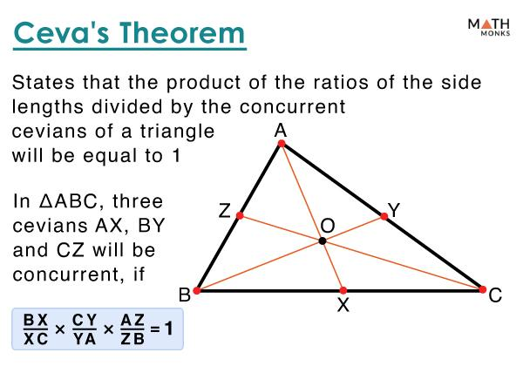
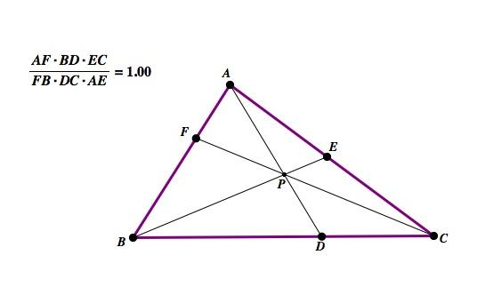
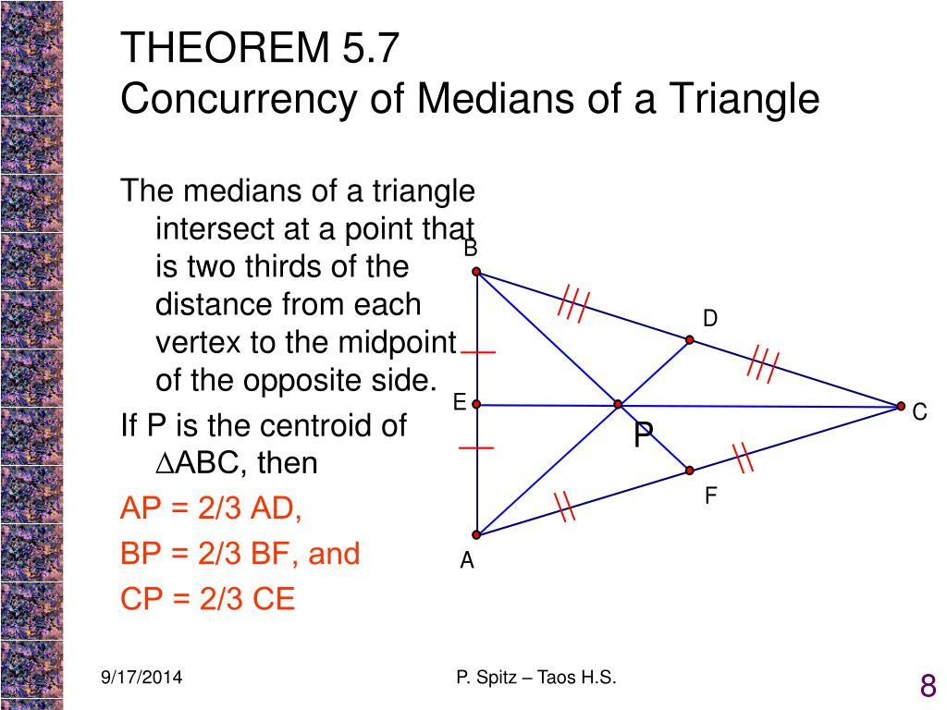
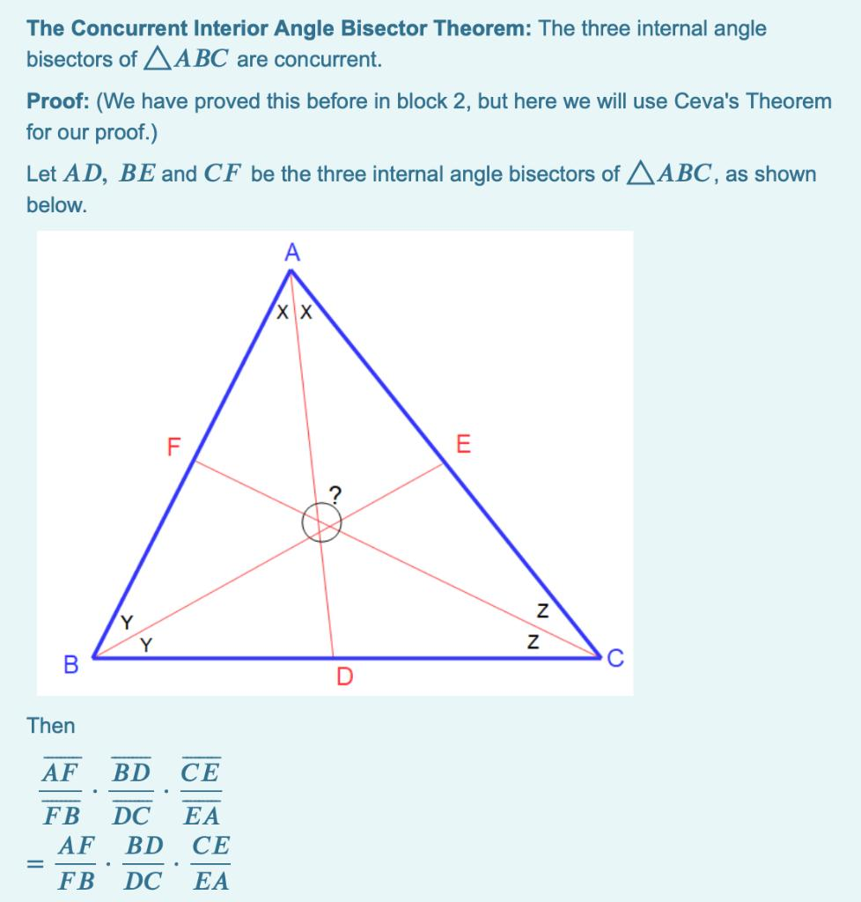

Definition
# Source: AI Source: Provided by: [Data Path: Persons Table -> ID Column: 1, Name_En Column: Motasem Essam] -> From: [ChatGPT] on [7/25/2026]
Ceva's Theorem is a theorem in triangle geometry that gives a condition for determining whether three cevians of a triangle are concurrent.
A cevian is a line segment drawn from a vertex of a triangle to a point on the opposite side, or on its extension.
For triangle $△ABC$, let:
- $D$lie on $BC$
- $E$lie on $CA$
- $F$lie on $AB$
Then the cevians
$$AD, BE, CF$$
are concurrent if and only if:
$$\boxed{\frac{BD}{DC}⋅\frac{CE}{EA}⋅\frac{AF}{FB}=1}$$
This is the converse-and-forward form of Ceva's Theorem.
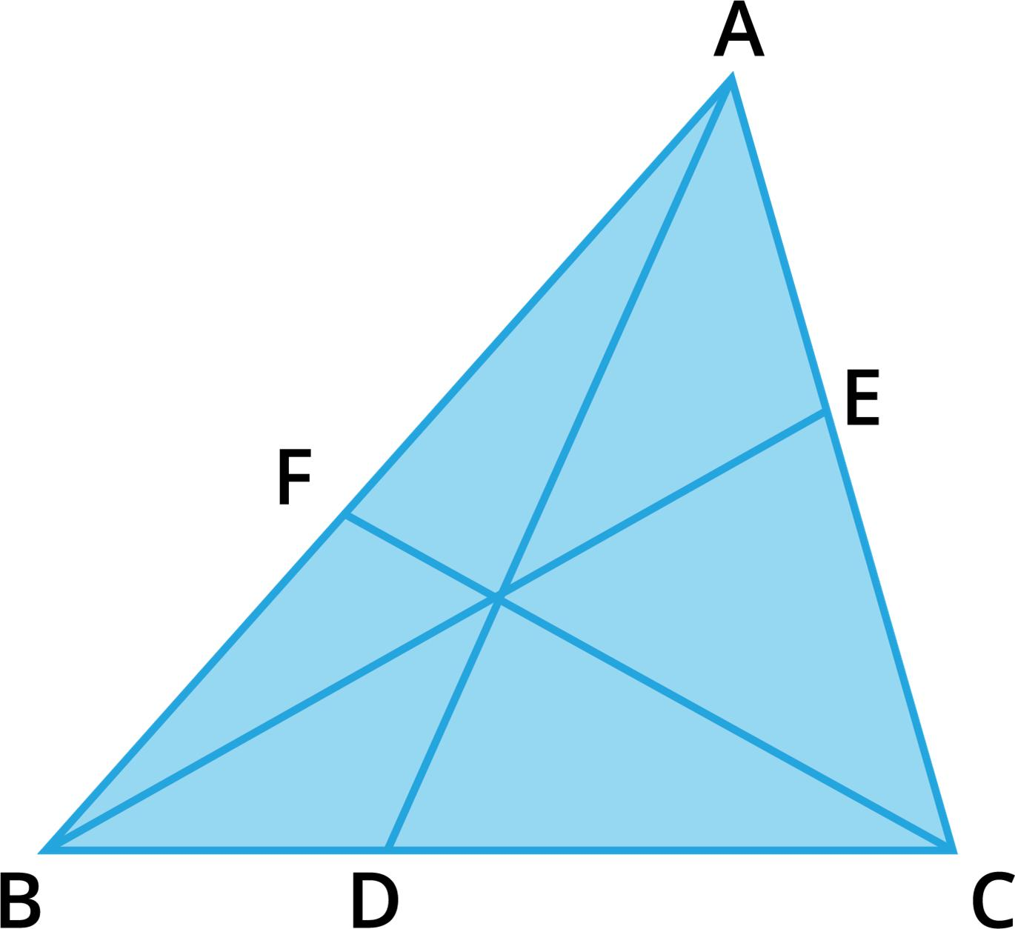

Simple Definition
# Source: AI Source: Provided by: [Data Path: Persons Table -> ID Column: 1, Name_En Column: Motasem Essam] -> From: [ChatGPT] on [7/25/2026]
Ceva's Theorem tells us when three lines drawn from the vertices of a triangle to the opposite sides meet at one common point.
The central idea is:
$$\boxed{\text{Three Cevians are concurrent }⟺\text{ Product of three side ratios}=1}$$

Fundamental Configuration
# Source: AI Source: Provided by: [Data Path: Persons Table -> ID Column: 1, Name_En Column: Motasem Essam] -> From: [ChatGPT] on [7/25/2026]
Consider $△ABC$:
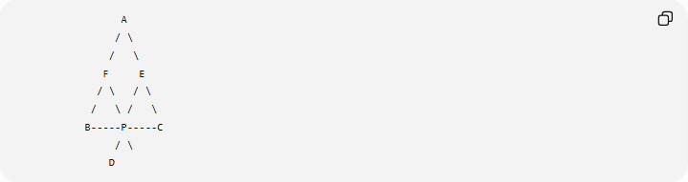
A
/ \
/ \
F E
/ \ / \
/ \ / \
B-----P-----C
/ \
D
A more standard arrangement is:
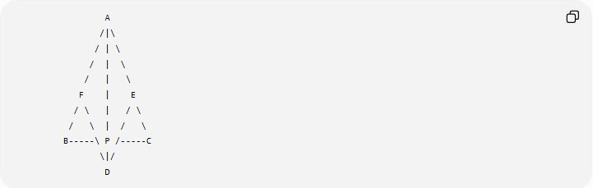
A
/|\
/ | \
/ | \
/ | \
F | E
/ \ | / \
/ \ | / \
B-----\ P /-----C
\|/
D
where:
$$D∈BC, E∈CA, F∈AB$$
and:
$$AD, BE, CF$$
meet at the same point $P$.
The three lines are therefore concurrent.

What Is a Cevian?
# Source: AI Source: Provided by: [Data Path: Persons Table -> ID Column: 1, Name_En Column: Motasem Essam] -> From: [ChatGPT] on [7/25/2026]
A cevian is a line segment connecting a vertex of a triangle to a point on the opposite side.
For example:
$$D∈BC$$
means $D$lies on side $BC$.
Therefore:
$$\boxed{AD\text{ is a cevian}}$$
Similarly:
$$\boxed{BE\text{ and }CF\text{ are cevians}}$$

Common Cevians
# Source: AI Source: Provided by: [Data Path: Persons Table -> ID Column: 1, Name_En Column: Motasem Essam] -> From: [ChatGPT] on [7/25/2026]
Important examples include:
- Median — connects a vertex to the midpoint of the opposite side.
- Angle bisector — connects a vertex to the opposite side while bisecting the vertex angle.
- Altitude — connects a vertex to the opposite side at a right angle.
Ceva's Theorem can therefore be applied to configurations involving medians, angle bisectors, altitudes, and general cevians.

Statement of Ceva's Theorem
# Source: AI Source: Provided by: [Data Path: Persons Table -> ID Column: 1, Name_En Column: Motasem Essam] -> From: [ChatGPT] on [7/25/2026]
For $△ABC$, with
$$D∈BC, E∈CA, F∈AB,$$
the cevians $AD$, $BE$, and $CF$are concurrent if and only if:
$$\boxed{\frac{BD}{DC}⋅\frac{CE}{EA}⋅\frac{AF}{FB}=1}$$
This is the standard internal Ceva theorem, where $D,E,F$lie on the sides themselves.

The Main Idea
# Source: AI Source: Provided by: [Data Path: Persons Table -> ID Column: 1, Name_En Column: Motasem Essam] -> From: [ChatGPT] on [7/25/2026]
Ceva's Theorem connects two things:
Geometric condition
$$\boxed{AD, BE, CF\text{ are concurrent}}$$
and
Algebraic condition
$$\boxed{\frac{BD}{DC}\frac{CE}{EA}\frac{AF}{FB}=1}$$
Therefore:
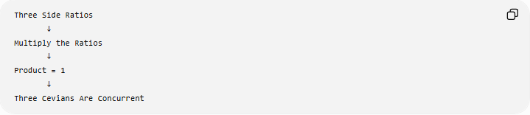
Three Side Ratios
↓
Multiply the Ratios
↓
Product = 1
↓
Three Cevians Are Concurrent
And conversely:
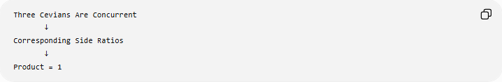
Three Cevians Are Concurrent
↓
Corresponding Side Ratios
↓
Product = 1

Example 1: Verify Concurrency
# Source: AI Source: Provided by: [Data Path: Persons Table -> ID Column: 1, Name_En Column: Motasem Essam] -> From: [ChatGPT] on [7/25/2026]
Suppose:
$$BD=2, DC=3 \\ CE=6, EA=4 \\ AF=2, FB=1$$
Calculate:
$$\frac{BD}{DC}⋅\frac{CE}{EA}⋅\frac{AF}{FB}$$
Substitute:
$$\frac{2}{3}⋅\frac{6}{4}⋅\frac{2}{1}$$
Simplify:
$$\frac{2}{3}⋅\frac{3}{2}⋅2 \\ =2$$
Since:
$$2≠1$$
the three cevians are not concurrent.

Example 2: A Concurrent Configuration
# Source: AI Source: Provided by: [Data Path: Persons Table -> ID Column: 1, Name_En Column: Motasem Essam] -> From: [ChatGPT] on [7/25/2026]
Suppose:
$$BD=2, DC=4 \\ CE=3, EA=6 \\ AF=6, FB=3$$
Then:
$$\frac{BD}{DC}=\frac{2}{4}=\frac{1}{2} \\ \frac{CE}{EA}=\frac{3}{6}=\frac{1}{2} \\ \frac{AF}{FB}=\frac{6}{3}=2$$
Therefore:
$$\frac{1}{2}⋅\frac{1}{2}⋅2=\frac{1}{2}$$
So these values do not satisfy Ceva's condition.
To make the product equal to $1$, for example, take:
$$AF=12, FB=3$$
Then:
$$\frac{AF}{FB}=4$$
and:
$$\frac{1}{2}⋅\frac{1}{2}⋅4=1$$
Therefore:
$$\boxed{AD, BE, CF\text{ are concurrent}}$$

Example 3: Find an Unknown Length
# Source: AI Source: Provided by: [Data Path: Persons Table -> ID Column: 1, Name_En Column: Motasem Essam] -> From: [ChatGPT] on [7/25/2026]
Suppose:
$$\frac{BD}{DC}=\frac{2}{3} \\ \frac{CE}{EA}=\frac{4}{5}$$
and:
$$AF=6$$
Find $FB$if the three cevians are concurrent.
By Ceva:
$$\frac{2}{3}⋅\frac{4}{5}⋅\frac{6}{FB}=1$$
Multiply:
$$\frac{8}{15}⋅\frac{6}{FB}=1 \\ \frac{48}{15FB}=1$$
Therefore:
$$48=15FB \\ FB=\frac{48}{15} \\ \boxed{FB=\frac{16}{5}}$$

Ceva's Theorem and Medians
# Source: AI Source: Provided by: [Data Path: Persons Table -> ID Column: 1, Name_En Column: Motasem Essam] -> From: [ChatGPT] on [7/25/2026]
One of the most important applications of Ceva's Theorem is proving that the three medians of a triangle are concurrent.
A median divides the opposite side into two equal parts.
Therefore:
$$BD=DC$$
so:
$$\frac{BD}{DC}=1$$
Similarly:
$$\frac{CE}{EA}=1$$
and:
$$\frac{AF}{FB}=1$$
Thus:
$$1⋅1⋅1=1$$
Therefore, by Ceva's Theorem:
$$\boxed{\text{The three medians are concurrent}}$$
Their common point is called the centroid.

Ceva's Theorem and Angle Bisectors
# Source: AI Source: Provided by: [Data Path: Persons Table -> ID Column: 1, Name_En Column: Motasem Essam] -> From: [ChatGPT] on [7/25/2026]
Suppose $AD$, $BE$, and $CF$are the internal angle bisectors of $△ABC$.
By the Angle Bisector Theorem:
$$\frac{BD}{DC}=\frac{AB}{AC}$$
Similarly:
$$\frac{CE}{EA}=\frac{BC}{BA}$$
and:
$$\frac{AF}{FB}=\frac{CA}{CB}$$
Multiplying:
$$\frac{AB}{AC}⋅\frac{BC}{BA}⋅\frac{CA}{CB}=1$$
Therefore:
$$\boxed{AD, BE, CF\text{ are concurrent}}$$
Their common point is the incenter.

Ceva's Theorem and Altitudes
# Source: AI Source: Provided by: [Data Path: Persons Table -> ID Column: 1, Name_En Column: Motasem Essam] -> From: [ChatGPT] on [7/25/2026]
The three altitudes of a triangle are also concurrent.
Their common point is the orthocenter.
Ceva's Theorem can be used to establish this concurrency, although the resulting side ratios are usually expressed using trigonometric relationships.
Thus:
$$\boxed{\text{The three altitudes are concurrent}}$$
at the orthocenter.

Generalized Ceva's Theorem
# Source: AI Source: Provided by: [Data Path: Persons Table -> ID Column: 1, Name_En Column: Motasem Essam] -> From: [ChatGPT] on [7/25/2026]
The standard theorem assumes that $D,E,F$lie on the sides of the triangle.
Ceva's theorem can also be extended to points on the extensions of the sides using directed lengths.
The directed-length form is:
$$\boxed{\frac{\overset{‾}{BD}}{\overset{‾}{DC}}⋅\frac{\overset{‾}{CE}}{\overset{‾}{EA}}⋅\frac{\overset{‾}{AF}}{\overset{‾}{FB}}=1}$$
when a consistent directed-segment convention is used.
This allows the theorem to handle external cevians as well as internal ones.

Ceva's Theorem vs Menelaus' Theorem
# Source: AI Source: Provided by: [Data Path: Persons Table -> ID Column: 1, Name_En Column: Motasem Essam] -> From: [ChatGPT] on [7/25/2026]
Ceva's and Menelaus' theorems are closely related.
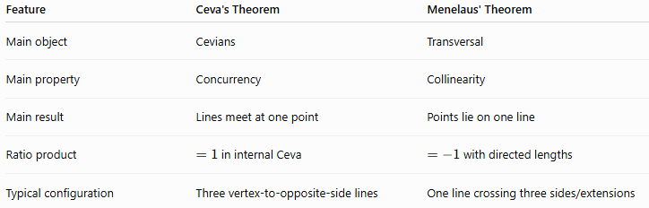
Feature | Ceva's Theorem | Menelaus' Theorem
Main object | Cevians | Transversal
Main property | Concurrency | Collinearity
Main result | Lines meet at one point | Points lie on one line
Ratio product | $=1$in internal Ceva | $=-1$with directed lengths
Typical configuration | Three vertex-to-opposite-side lines | One line crossing three sides/extensions
Conceptually:
$$\boxed{\text{Ceva}→\text{Concurrency}} \\ \boxed{\text{Menelaus}→\text{Collinearity}}$$

Important Terminology
# Source: AI Source: Provided by: [Data Path: Persons Table -> ID Column: 1, Name_En Column: Motasem Essam] -> From: [ChatGPT] on [7/25/2026]
Concurrent
Three or more lines are concurrent if they all pass through the same point.
$$\boxed{AD∩BE∩CF=P}$$
Collinear
Three or more points are collinear if they lie on the same line.
Cevian
A segment from a vertex of a triangle to the opposite side.
Ratio
A comparison between two lengths:
$$\frac{BD}{DC}$$

Proof Idea
# Source: AI Source: Provided by: [Data Path: Persons Table -> ID Column: 1, Name_En Column: Motasem Essam] -> From: [ChatGPT] on [7/25/2026]
A common proof of Ceva's Theorem uses areas.
Suppose $AD$, $BE$, and $CF$meet at $P$.
Triangles $PBD$and $PCD$have the same altitude from $P$to $BC$, so:
$$\frac{BD}{DC}=\frac{\left[PBD\right]}{\left[PCD\right]}$$
Similarly, corresponding area ratios can be obtained for the other sides.
Multiplying the three ratios causes the areas to cancel:
$$\frac{BD}{DC}⋅\frac{CE}{EA}⋅\frac{AF}{FB}=1$$
Thus the concurrency condition follows.

Classification
# Source: AI Source: Provided by: [Data Path: Persons Table -> ID Column: 1, Name_En Column: Motasem Essam] -> From: [ChatGPT] on [7/25/2026]
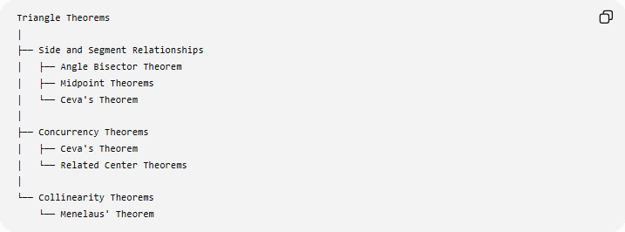
Triangle Theorems
│
├── Side and Segment Relationships
│ ├── Angle Bisector Theorem
│ ├── Midpoint Theorems
│ └── Ceva's Theorem
│
├── Concurrency Theorems
│ ├── Ceva's Theorem
│ └── Related Center Theorems
│
└── Collinearity Theorems
└── Menelaus' Theorem
Ceva's Theorem is particularly important as a triangle concurrency theorem.

Key Formula
# Source: AI Source: Provided by: [Data Path: Persons Table -> ID Column: 1, Name_En Column: Motasem Essam] -> From: [ChatGPT] on [7/25/2026]
For $△ABC$:
$$D∈BC, E∈CA, F∈AB$$
then:
$$\boxed{AD, BE, CF\text{ are concurrent }⟺ \frac{BD}{DC}\frac{CE}{EA}\frac{AF}{FB}=1}$$

Key Points
# Source: AI Source: Provided by: [Data Path: Persons Table -> ID Column: 1, Name_En Column: Motasem Essam] -> From: [ChatGPT] on [7/25/2026]
- Ceva's Theorem deals with concurrency.
- It applies to three cevians of a triangle.
- A cevian connects a vertex to the opposite side.
- The standard internal formula is:
$$\boxed{\frac{BD}{DC}\frac{CE}{EA}\frac{AF}{FB}=1}$$
- The theorem works in both directions:
  - concurrency $⇒$ratio product $=1$;
  - ratio product $=1⇒$concurrency.
- It can be used with medians, angle bisectors, and other cevians.
- The common intersection of the three medians is the centroid.
- The common intersection of the three internal angle bisectors is the incenter.
- The generalized form uses directed lengths for points on side extensions.
- Ceva is closely related to Menelaus, but Ceva concerns concurrency, while Menelaus concerns collinearity.

Conclusion
# Source: AI Source: Provided by: [Data Path: Persons Table -> ID Column: 1, Name_En Column: Motasem Essam] -> From: [ChatGPT] on [7/25/2026]
Ceva's Theorem provides an algebraic condition for the concurrency of three cevians in a triangle:
$$\boxed{\text{Three Cevians Concurrent }⟺ \frac{BD}{DC}⋅\frac{CE}{EA}⋅\frac{AF}{FB}=1}$$
Its central relationship is:
$$\boxed{\text{Side Ratios}⟷\text{Concurrency}}$$
It is one of the fundamental theorems for studying triangle centers, cevians, ratios, and concurrency.

